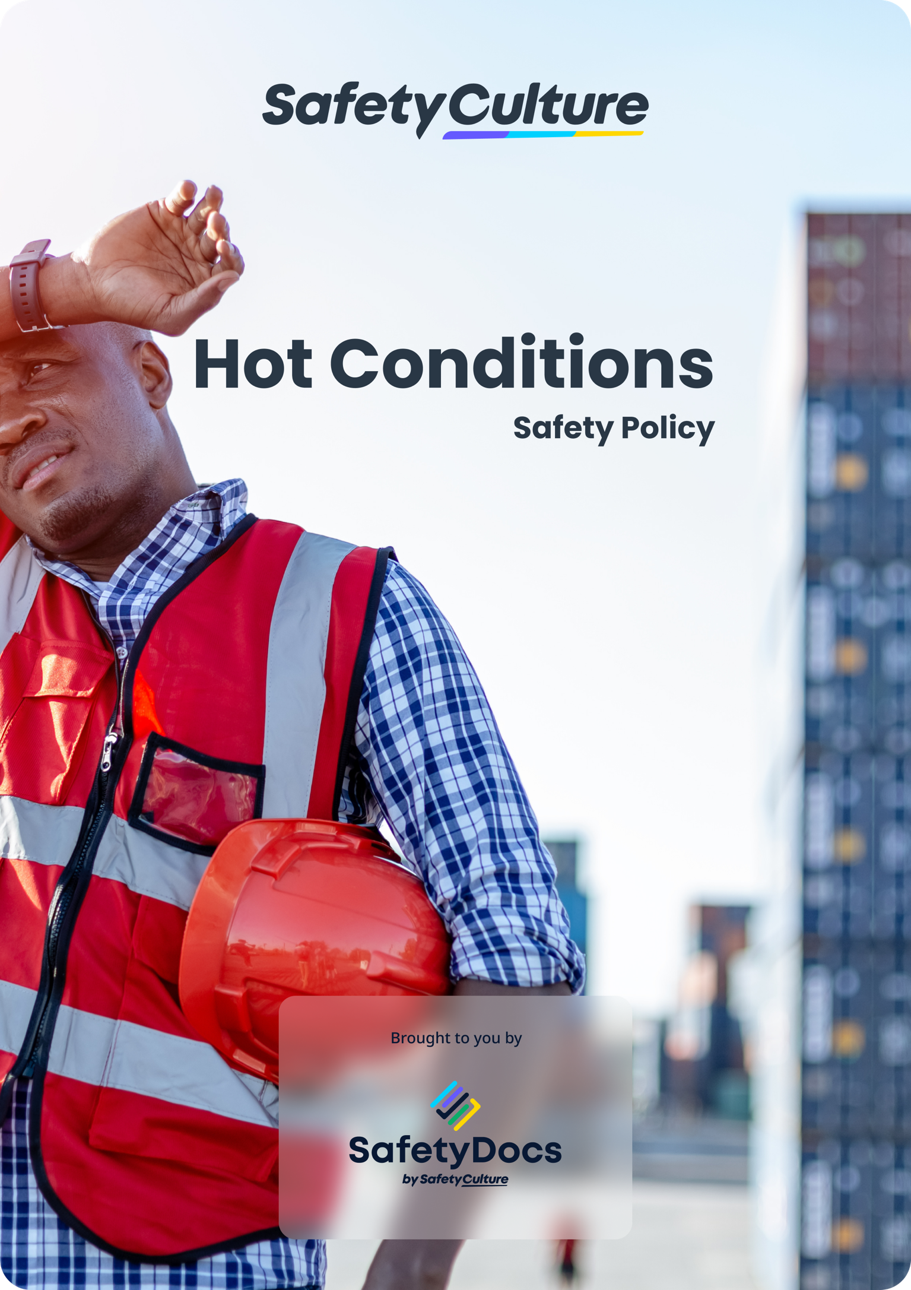
(REMOVABLE FIRST PAGE)

Hot Conditions Safety Policy
(Add your preferred heading)
+
(add your company logo here)

Company name
Company address
ABN/NZBN
Disclaimer: This document contains material to assist in addressing Occupational Health and Safety management obligations. Although every effort has been made to ensure the accuracy of this information at the time of publication, it is provided as guidance only. It does not provide legal advice on meeting your obligations.
This template is being provided as part of a limited-time campaign in recognition of the World Day for Health and Safety at Work on April 28, 2024. The provision of this template does not entitle the user to updates, revisions, or ongoing support from SafetyCulture or its related entities.
Copyright © SafetyCulture All Rights Reserved

Introduction to Hot Conditions Safety 4
Review Procedure 4
References 4
Standards and Guidelines 4
Terminology 5
Document Control 5
Hot Conditions Safety 6
Responsibilities 7
Hot Conditions Safety Procedures 8
Hot Conditions Risk Assessment Form 9

Introduction to Hot Conditions Safety
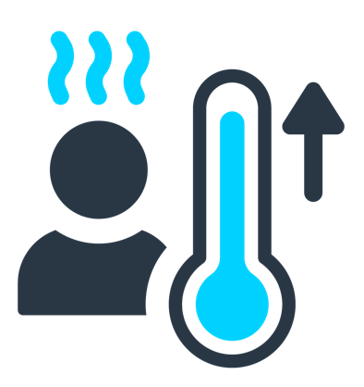 | Workers who work in hot conditions have a higher than average risk of harm due to hot and or humid conditions.  Operations involving high air temperatures, radiant heat sources, high humidity and strenuous physical activities have a high potential for causing heat-related illness.  Outdoor operations conducted in hot weather and direct sun, such as construction work, landscaping, and similar activities also increase the risk of heat-related illness in exposed workers.

Review Procedure
The Managing Directors will review the policy as required. The review schedule is directed in response to organisational and/or legislative changes and requirements. The review will be undertaken in consultation with workers, company representatives, and other relevant parties. All relevant persons will be made aware of changes made because of the review.
This policy will be reviewed if:
- there are changes in the workplace that may affect the policy;
- the policy is not effective;
- there are legislative changes that affect the policy;
- there is a breach of this policy.
This policy is reviewed at least annually.

References
How to add your references

Step 1: Click the link below to download your reference list (save it to an appropriate location on your computer).
Step 2. Open the reference list document and Copy and Paste the relevant references into this section.
Step 3. Remember to remove this instruction before adding references.
Legislation and Codes of Practice Reference List Download

Standards and Guidelines
ISO 45001:2018 Occupational Health and Safety Management Systems.
Insert any standards or guidelines applicable to your industry.

Terminology
Abbreviations and Acronyms
AS/NZS: Australian Standards/New Zealand Standards.  BOM: Bureau of Meteorology.  PPE: Personal Protective Equipment. | - For this policy, no specific references will be made to the terms Health, Safety at Work (HSW), Work Health and Safety (WHS), we will refer to Occupational Health and Safety (OHS) as per the Australian Standard/New Zealand Standard (AS/NZS) International Organisation for Standardisation (ISO) 45001:2018.
Definitions
AS/NZS ISO 45001: International audit tool system intended to audit OHSMS and provide international OHS benchmarks.
Hot stress – is the sum of environmental effects that overexposure to high temperatures can have on a person. These effects may range from discomfort to physical harm, causing death.
Hyperthermia – is an abnormally high body temperature or overheating. If the condition is not recognised and treated, death can result.
We, us, our, our company or the organisation" means {company_name}.
Worker: is a person who carries out work in any capacity for an Organisation, including work as:
- An employee, or  - Outworker, or  - An apprentice or trainee, or  - A student gaining work experience, or  - A volunteer, or | - A person of a prescribed class, or  - A contractor or subcontractor, or  - A worker of a contractor or subcontractor, or  - A worker of a labour-hire company.
Workplace – means a place where work is carried out for a business or undertaking and includes any place where a worker goes or is likely to be while at work. A workplace includes:
- A vehicle, vessel, aircraft, or other mobile structure; and
- Any waters and installations on land, on the bed of any waters or floating on any waters.

Document Control
Distribution Record Register
Copy | Issued to |  |  |  | Controlled Copy |  |  | Authorised by |  | Recipient Signature |  | Issue Date
 |  |  |  |  | Y |  | N
1
2
3
4
5
Amendment Record Register |  |  |  |  |  |  |  |  | Issue #: 1
 |  |  |  |  |  |  |  |  | Issue Date:
Rev. # |  | Date | Details |  |  | Description of Changes |  |  |  |  | Approved By
 |  |  | Section # | Para. #
1
2
3
4
5

Hot Conditions Safety
Objective
To provide workers with information for protecting themselves where hot work conditions may cause serious injuries/illnesses to occur. Every worker is expected to follow the guidelines provided in this section.
Scope
This policy covers all workers exposed to hot conditions long enough to cause a risk to health.
Policy
{company_name} will endeavour to eliminate or reduce the number and severity of injuries caused by hot conditions. This will be done by implementing procedures to identify and manage hot conditions hazards and the associated risks arising from those hazards.
In consultation with relevant persons, the organisation will ensure all tasks that have a potential for heat stress as a hazard are identified before work commences and also throughout a project as required.
To reduce the risk of injury or illness from exposure to hot conditions, {company_name} will:
- provide appropriate protective clothing;
- ensure all protective equipment AS/NZS;
- understand the warning signs and symptoms of heat stress conditions:
- fatigue;
- nausea;
- headache;
- excessive thirst;
- muscle aches and cramps;
- weakness;
- confusion or anxiety;
- develop training and awareness programs to include:
  - health effects of exposure to hot conditions;
  - factors affecting apparent temperature (humidity, temperature);
  - correct use of various hot protection measures;
  - early detection of the possible sign of heat stress;
  - hazard and risk identification.

Responsibilities
{company_name} is responsible for:
- conduct a risk assessment, in consultation with workers to identify any workers who have a risk of exposure to heat stress.
Supervisors/ managers have a responsibility to:
- ensure workers are familiar with the {company_name} Hot conditions policy and procedure and are trained and competent in the correct use of PPE and clothing;
- advise workers that the BOM/Metservice provide hot weather forecasts assist workers to develop control measures while working outdoors;
- ensure all workers at risk from exposure to hot conditions have access to adequate and appropriate PPE and clothing;
- ensure all workers wear and apply for hot conditions protection PPE and clothing when required;
- monitor and review the Hot Conditions Safety Policy and procedure regularly.
Workers have a responsibility to:
- take reasonable care for their own health regarding working in hot conditions;
- identify and report hot conditions risks encountered throughout carrying out work;
- correctly wear and use PPE and clothing during work hours;
- not to intentionally misuse or damage PPE or clothing;
- inform their manager/supervisor of any damage to, defect in, or need to clean or decontaminate any PPE or clothing.

Signature: | Date:
(To be signed by Director/Business Owner)

Hot Conditions Safety Procedures
The following hot conditions Safety strategies are in place at all {company_name} worksites:
- risk assessments are conducted, in participation with relevant workers, to identify situations where and when workers may be at risk from exposure to hot conditions and heat stress. Risk assessments take into consideration factors such as the potential for high temperatures and humid conditions and ensuring that wearing or use of PPE and/or protective clothing does not create other hazards or risks to workers (e.g., hats may get caught in machines causing injuries);
- workers who work remotely or in isolation at the worksites should organise work to avoid the hottest days or seasons where possible;
- rotation of tasks to minimise periods of prolonged physical activity;
- cooling/shade is provided for workers wherever possible;
- water is provided for workers and where necessary liquid electrolyte replacement;
- appropriate lightweight, protective clothing is provided to workers as required;
- PPE and clothing meets accepted AS/NZS;
- training and awareness programs are conducted for workers who are required to undertake work in hot conditions;
- toolbox talks/safety meetings include reminders about the dangers of hot conditions;
- provision of a First Aid kit, with appropriate instructions and treatment for heat-related illness. (First Aid staff should be given appropriate training in providing initial treatment for heat stress conditions.)
Extra consideration should be undertaken for work conducted above 30 degrees Celsius. The following table can be used as a guide to managing exposure to hot conditions:
Temperature | Rest break
30º - 32º | A 10-minute break per hour
32º - 35º | A 15-minute break per hour
35º - 36º | A 30-minute break per hour
37º Celsius and higher | Consider stopping work until a sustained temperature decrease.
- 37º Celsius is a critical temperature; there is a significant risk of increasing body temperatures to the point where is a danger of Heat Stroke.
If a worker appears to be suffering from heat stress:
- get the person into the shade;
- start cooling down the body as soon as possible;
- remove or loosen clothing;
- if the person is conscious and not vomiting, help them to drink as much as possible, in small sips;
- pour cool water on their neck and wrists and or apply wet towels or wet sheets to their body;
- if there is ice on site, place ice packs in their armpits and groin area. (closest to blood flow) (if they begin to shiver, remove the ice or cold blanket);
- fan them with a piece of paper, shirt or another item to keep airflow up;
- stay with the person;
- get the person medical care as soon as possible.

Hot Conditions Risk Assessment Form
Location of Task: |  | Management Rep:
Description of the task: |  | Health and Safety Rep:
Date of assessment: | Workers, others (consultants, etc.):
Reason for Identification: Existing task New task Change in a task, object or tool New information Report of hot conditions injury

Indicate 'yes' for the hazard. | Yes | Description of hazard | If any boxes are ticked, what are possible controls to reduce the risk
Environmental Conditions: Can the workers' heat stress levels be increased or affected by the environmental conditions at the workplace?
Extreme hot weather  Adverse weather conditions  Unshaded outdoor work  Heavy Physical work  Other – specify: |  |  | Elimination - can the work or environment be altered so that hot conditions are no longer a problem? Yes No  Detail control measures – Example control measures shown - Replace or add with control measures applicable to your circumstances  Where the atmospheric temperature may be above 25 degrees Celsius a suitable thermometer will be provided to monitor temperature changes.  Safe work method procedures developed for working in hot conditions  Training for recognition of the symptoms of heat stress or injury  Develop emergency procedures for heat stroke  Supply hot conditions PPE to suit, nature of the work, temperature and, the level of activity.  Provide access to fluid replacement and shade (sufficient water)
Work Location: Can the workers heat stress levels be increased or affected by the location/s of the workplace?
Work in water  Work at altitude  Remote Location  Isolated workers  Other- specify: |  |  | Elimination - can the work be undertaken at a different location? Yes No  Detail control measures – Example control measures shown - Replace or add with control measures applicable to your circumstances  Consideration when planning and conducting projects in summer months (e.g. Dec to March)  Provide a cooled space for workers to take rest breaks  Safe work method procedure developed for working in Remote location  Ensure at least two workers in isolated areas
Plant, machinery, equipment: Can the workers heat stress levels be increased or affected by the use or operation of plant, machinery, equipment?
Open/Partly enclosed cab mobile plant  Un-air conditioned mobile plant  Lack of ventilation  Potential for bare skin contact with hot metal surfaces  Other - specify: |  |  | Elimination - can the task or plant, machinery or equipment be eliminated so that excessive heat is no longer a problem? Yes No  Detail control measures - Example control measures shown - Replace or add with control measures applicable to your circumstances  Thermal insulating materials added to metal handles  Shielding a person from the hot environment, e.g. high radiant heat source  Work conducted at a different time, e.g. night time (Isolation)  Provide cooling to mobile plant  Safe work method procedure developed for working in a hot area
Worker factors: Can the workers heat stress levels be increased or affected by worker factors?
Female workers (less capacity for metabolic cooling)  Mature aged workers  Workers with circulatory diseases  Injured/sick workers  Workers returning from injury  Workers under the influence of alcohol/drug  Other – specify: |  |  | Elimination - can the work be undertaken by another person with lower risk factors? Yes No  Detail control measures - Example control measures shown - Replace or add with control measures applicable to your circumstances  Provide a cooled space for workers to take rest breaks  Rotation of workers to reduce time spent in hot conditions  Buddy system and monitor other workers for signs and symptoms of heat stress  Medical fitness assessment
Work hours: Can the workers' heat stress levels be increased or affected by the time spent in hot conditions?
Number of work hours per shift:  Less than 4 hours  Up to 8 hours  8 to 10 hours  10 to 12 hours  Above 12 hours  Temperature:  less than 20°C  20°C -30°C  30°C to - 37°C  Above 37°C ( Emergency Only)  Other – specify: |  |  | Elimination - can the work be undertaken in shorter blocks of time? Yes No  Detail control measures - Example control measures shown - Replace or add with control measures applicable to your circumstances  Safe work method procedure developed for working in hot conditions  Develop maximum working times and cooldown/drink breaks based on temperature/wind speed/humidity ( see guidelines for the management of extremes of temperature (Worksafe) http://www.business.govt.nz/worksafe/information-guidance/guidance-by-hazard-type/temperature  Ensure at least two workers in isolated areas

